Spacecraft Orbit Estimation via Batch Initialized Kalman Filtering
  - Dylan D’Silva

Project Overview
I developed a MATLAB-based orbit determination and statistical estimation framework to evaluate the convergence behavior and robustness of multiple spacecraft state estimation algorithms. The simulation modeled a low Earth orbit spacecraft observed by a ground station measuring slant range, azimuth, and elevation. The true trajectory captured the effects of the Earth J2 perturbation while all estimators assumed simplified two-body dynamics. This intentional model mismatch allowed evaluation of estimator sensitivity to nonlinear propagation error, quality of estimate initialization, and unmodeled dynamics. Implemented estimators included:
- Batch Least Squares (BLS)
- Recursive Least Squares with Forgetting Factor (RLS-FF)
- Gauss Least Squares Differential Correction (GLSDC)
- Extended Kalman Filter (EKF)
- Unscented Kalman Filter (UKF)
The primary objective was not only to compare nominal estimation accuracy, but also to investigate:
- Estimator convergence under poor initialization
- Nonlinear filter transient behavior
- Robustness to modeling error
- Divergence in batch estimation methods
- Performance improvements from hybrid estimation architectures

Implementation

Dynamics and Measurement Modeling
The spacecraft’s trajectory was propagated using nonlinear orbital dynamics including the Earth J2 perturbation. Estimators propagated states using a simplified two-body gravity model. This intentionally introduced modeling inconsistency between the truth and estimation dynamics.
Ground-based measurements were generated from simulated spacecraft motion using slant range, azimuth, and elevation. Measurement noise was modeled as zero-mean Gaussian noise with independent covariance terms for each observation channel.
The measurement model transformed inertial position vectors into the observer’s local East-North-Up frame before computing observable quantities. I implemented the full nonlinear measurement model and derived analytic Jacobians required for linearized estimators and covariance propagation.
Propagation of the state and state transition matrix integration were implemented using adaptive Runge-Kutta numerical integration with tight tolerances to ensure numerical integration error remained well below measurement noise levels.

Estimator Architecture
BLS and GLSDC estimated the spacecraft initial state by minimizing measurement residuals over a finite observation arc using iterative linearization. These methods relied heavily on local linearity assumptions and were sensitive to poor initial conditions over long propagation intervals. RLS-FF was implemented as a recursive estimator with exponential memory weighting. These methods were used to determine the initial satellite state, which could then be propagated forward in time.
The EKF linearized system dynamics and measurements about the current state estimate and propagated covariance using the state transition matrix. The UKF instead propagated sigma points through nonlinear dynamics to better capture higher-order nonlinear effects without explicit linearization. Both filters were evaluated under intentionally poor initial state knowledge to analyze transient behavior and convergence sensitivity.

Hybrid Architecture
The EKF and UKF exhibited large transient estimation errors when initialized with poor state estimates, but both converged after sufficient measurements were collected. To improve the convergence of these filters, I implemented a hybrid estimation architecture using short-arc GLSDC estimation to initialize the EKF and UKF.
The process consisted of three steps. I performed batch estimation over a short interval containing early measurements using GLSDC. I then propagated the estimated state forward to just after the batch estimator stopped collecting measurements and the sequential filters started. The propagated state and covariance were used to initialize the EKF and UKF. This hybrid approach significantly reduced transient filter errors caused by the poor initial states and improved the convergence stability overall.

Results and Analysis
Estimator performance was evaluated using trajectory root-mean-square error against the true trajectory over the full observation interval.

Method | Position RMSE (km) | Velocity RMSE (km/s)
BLS | 3477.2 | 12.818
RLS-FF | 4247.9 | 14.546
GLSDC | 0.1866 | 0.0018
EKF | 5.1302 | 3.6188
UKF | 1.497 | 0.97042
Using GLSDC for the first 30 time steps to produce an initial estimate, the EKF and UKF had the following RMSE for estimates after the 30th time step.
Method | Position RMSE (km) | Velocity RMSE (km/s)
EKF | 1.9075 | 0.1464
EKF + GLSDC | 0.0893 | 0.0047
UKF | 0.1685 | 0.0122
UKF + GLSDC | 0.0893 | 0.0047
With the hybrid approach, both the EKF and UKF showed significant improvements, achieving position RMSE below 100 meters and velocity RMSE of a few meters per second.

Key Findings
- BLS demonstrated sensitivity to initial estimates and observation length under nonlinearities.
- GLSDC demonstrated stable convergence and provided accurate initialization for the sequential filters.
- RLS-FF demonstrated the largest standalone trajectory RMSE.
- UKF showed robustness for the poor initial guess, while the EKF struggled when initial guesses could be beyond the validity of linearization.
- For the moderately nonlinear dynamics, the EKF and UKF converged to roughly the same behavior after transient responses.
- Initializing with a batch method significantly reduced EKF and UKF RMSE error.
- After batch initialization, EKF and UKF achieved nearly identical steady-state estimation performance for the moderately nonlinear dynamics considered.
I additionally implemented a Monte Carlo analysis of the GLSDC estimator to evaluate the covariance consistency and repeatability of the GLSDC under randomized measurements.
Figure 1 shows the position error magnitude over time for all five estimators. The base EKF and UKF exhibit large transients before converging, while the hybrid GLSDC-initialized filters (dashed) start an order of magnitude lower and avoid the transient entirely. Figure 2 shows position error and 3σ covariance bounds for the EKF and UKF. Both filters converge with errors tracked inside the predicted bounds, though the UKF transient is shorter and lower in magnitude than that of the EKF.
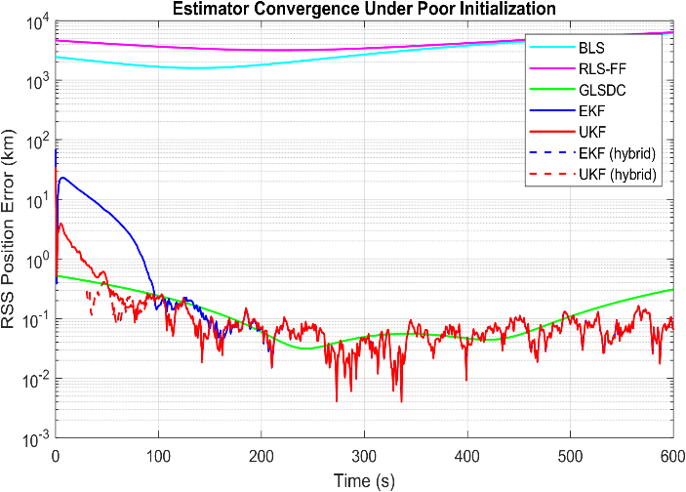
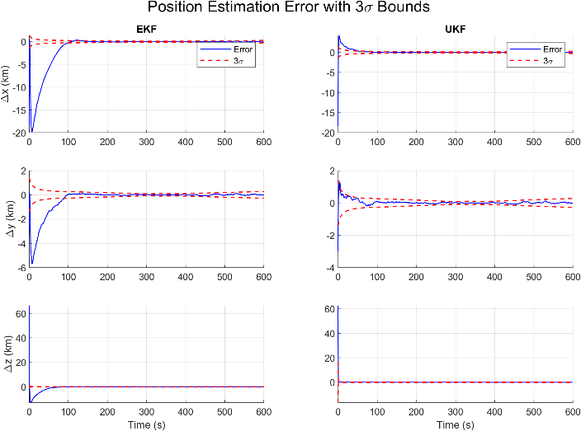
Figure 1
Figure 2

My Contributions
I implemented the complete MATLAB framework: the J2 perturbed dynamics, two-body estimator dynamics, measurement model, state transition matrix propagation and all five estimation algorithms (BLS, RLS-FF, GLSDC, EKF, UKF) and the GLSDC Monte Carlo Analysis.
The algorithms were implemented using Statistical Orbit Determination by Tapley, Schutz, and Born.

